

**Vocational Nursing Application Materials Submission - 2 Step Process**

**Read the Following Instructions Carefully.** After completing the Vocational Nursing Prerequisite Courses, the five designated sections of the HESI A2 test (scoring a minimum of 80% on all required sections) or TEAS exam (scoring a minimum of 55% on all required sections), uploading a current physical exam, tuberculosis screening, required immunizations, Health Insurance and Automobile Insurance and BLS- Basic Life Support CPR (cardiopulmonary resuscitation) certification documentation to **Castle Branch**, the applicant is ready to submit their application materials.

*Step 1:* Request access to Secure Link to upload all application documents, by emailing [AlliedHealthAdmissions@dallascollege.edu](mailto:AlliedHealthAdmissions@dallascollege.edu). The subject line of the email must be **Vocational Nursing** **Program Application Materials**.

*Step 2:* Use the depiction below as a reference on how to use the Secure Link. The application materials must be scanned as pdf documents. Although the line states to enter first name and then last name, please enter your last name in the first name space and your first name in the last name space for alphabetical purposes.

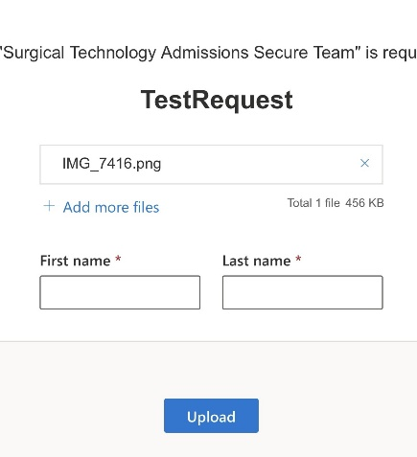

Applicants will receive an email from an Allied Health Admissions Specialist requesting the applicant “**Upload Files**”.

Click the **“Upload Files”** link; Select **“Add more files”** attach your PDF application materials; Input your name information and click **“Upload.”**

Upload the following required application materials to the secure link before the application filing deadline to be considered a complete and valid applicant:

* 1. **Completed** [Vocational Nursing Application and Signed Statement of Students’ Responsibility forms](https://www.dallascollege.edu/cd/credit/pages/ecc-health-packets-sessions.aspx)
  2. _____ **Documentation of TSI compliance on a transcript, advising report, score sheet, etc.**
  3. _____ **Original HESI A2 score sheet(s) or TEAS test score sheet.**
  4. _____ **Photocopy of high school transcript, high school diploma, or GED certificate.**
  5. _____ **Photocopy of your official Phi Theta Kappa membership card/certificate (if applicable).**
  6. _____ **Patient care/health care experience documentation (if any).**
  7. _____ **Copies of any request for course substitution forms (for evaluated transferred courses) or 5-year waiver forms that have been granted to the student**.

**Note: Submitting incomplete application materials will disqualify the application and the student will not be considered further in the application process. Students are advised to retain a photocopy of all materials submitted as their application and to Castle Branch.**

**Note:** Applicants are solely responsible for ensuring that their current official transcripts from ALL PREVIOUSLY ATTENDED COLLEGES AND UNIVERSITIES (excluding Dallas Colleges) are submitted to[**studenttranscripts@DallasCollege.edu**](mailto:studenttranscripts@DallasCollege.edu) **or to** Dallas College, Attention: Admissions Processing, 3737 Motley Drive, Mesquite, TX 75150 prior to applying to a Dallas College health sciences program. Official transcripts must have a print date no earlier than three years of anticipated entry to a health sciences program.