**Read the Following Instructions Carefully.** After completing the Occupational Therapy Assistant Prerequisite Courses, the TEAS test, observation hours, and uploading the required physical exam, immunization, and CPR (cardiopulmonary resuscitation) certification documentation to SurPath, the applicant is ready to submit their application materials.

*Step 1:* Request access to the Secure Link by completing the online [Secure Link Request Form](https://forms.office.com/pages/responsepage.aspx?id=U1R-1i9z3EqUpEiI8tl9XUakwsM_5KVEgQl5nK5D38ZUMTdSWFZVNkNCTTJYRTVXOFZVOFZIN1pHNiQlQCN0PWcu&route=shorturl).

*Step 2:* Use the depiction below as a reference on how to use the Secure Link. The application materials must be scanned as pdf documents. Although the line states to enter first name and then last name, please enter your last name in the first name space and your first name in the last name space for alphabetical purposes.

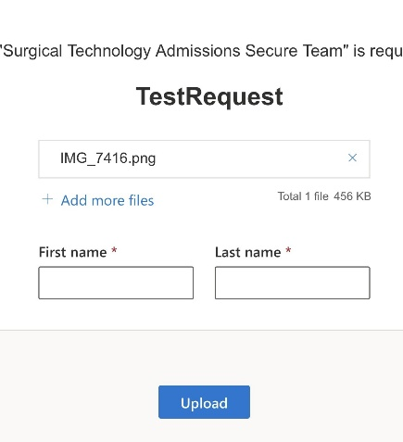

Applicants will receive an email from an Health Occupations Admissions Specialist requesting the applicant “**Upload Files**”.

Click the **“Upload Files”** link; Select **“Add more files”** attach your PDF application materials; Input your name information and click **“Upload.”**

Upload the following required application materials to the secure link before the filing deadline to be considered a complete and valid applicant:

1. A completed [**Occupational Therapy Assistant Program Application**](https://www.dallascollege.edu/cd/credit/pages/ecc-health-packets-sessions.aspx)and the signed **Statement of Students’ Responsibility form**.
2. [TEAS](https://www.atitesting.com/teas/register) score sheet indicating score of 55 or higher.
3. All observation feedback forms (found in [OTA Program Information Packet](https://www.dallascollege.edu/cd/credit/pages/ecc-health-packets-sessions.aspx)) or certificates of completion with signatures. Reflection on at least three (3) hours of occupational therapy exploration
4. One (1) recommendation forms/letters (forms found in [OTA Program Information Packet](https://www.dallascollege.edu/cd/credit/pages/ecc-health-packets-sessions.aspx)).
5. Photocopy of your Social Security card.
6. Photocopy of your Driver License or State ID card.
7. Letter verifying previously earned credentials or training from a related field that demonstrates prior knowledge.

**Note:** Applicants are solely responsible for ensuring that their current official transcripts from ALL PREVIOUSLY ATTENDED COLLEGES AND UNIVERSITIES (excluding Dallas Colleges) are submitted to[**studenttranscripts@DallasCollege.edu**](mailto:studenttranscripts@DallasCollege.edu) **or to** Dallas College, Attention: Admissions Processing, 3737 Motley Drive, Mesquite, TX 75150 prior to applying to a Dallas College health sciences program. Official transcripts must have a print date no earlier than three years of anticipated entry to a health sciences program.