Read the following instructions carefully when applying to the Dallas College Dental Hygiene Program. Incomplete application materials are not accepted, and the application will be disqualified. Students are advised to retain a photocopy of all materials submitted as their application and to SurPath.

Step 1: Download and thoroughly read and follow the direction in the Dental Hygiene Program Information Packet.

Step 2: Complete the following general requirements for admission found in the Dental Hygiene Program Information Packet.
- Complete an application for college admission, (if not already a Dallas College student).
- Submit official transcripts from all previously attended high schools and colleges/universities. Note: Applicants are solely responsible for ensuring that their current official transcripts from ALL PREVIOUSLY ATTENDED COLLEGES AND UNIVERSITIES (excluding Dallas Colleges) are submitted to studenttranscripts@DallasCollege.edu OR to Dallas College, Attention: Admissions Processing, 3737 Motley Drive, Mesquite, TX 75150 prior to applying to a Dallas College health sciences program. Official transcripts must have a print date no earlier than three years of anticipated entry to a health sciences program.
- Complete prerequisite courses in the time frame listed in the dental hygiene information packet.
- Register for the required HESI exam and complete written essay on one of the following four dates at the Dallas College El Centro Paramount building:
    - Friday November 15, 2024
    - Friday December 13, 2024
    - Wednesday January 22, 2025
    - Thursday February 13, 2025

Step 3: Application Submission
- Request access to the Secure Link by completing the online Secure Link Request Form.
- Upload the following items found in the Dental Hygiene Program Information Packet in ONE PDF document in this order: Completed Dental Hygiene Program Application Form, Signed Statement of Student’s Responsibility Form, HESI A2 Admissions Exam Score Sheet, Observation Hours, Criminal history evaluation from the Texas State Board of Dental Examiners, if applicable.
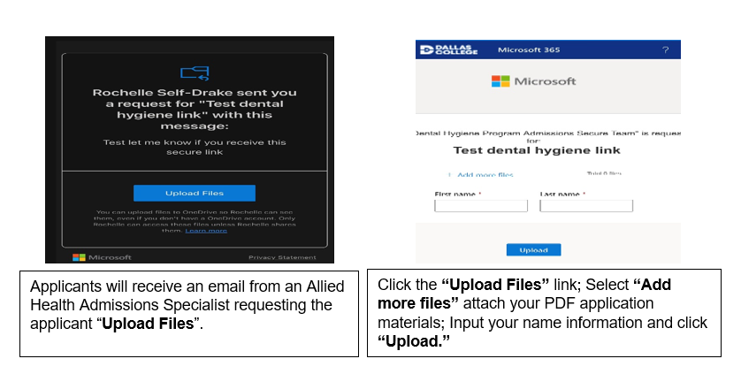
Step 4: SurPath
- Upon acceptance to the program, the student has 10 days to upload the following documents to the SurPath system: immunization records, tuberculosis screening, physical examination form (3 pages), proof of health insurance, American Heart Association BLS with AED.
- Information regarding SurPath is found in the Dental Hygiene Program Information Packet.

