1. Go to [https://evolve.elsevier.com](https://evolve.elsevier.com/)
2. Click ‘Sign in’ on upper-right corner and click on ‘Create account’

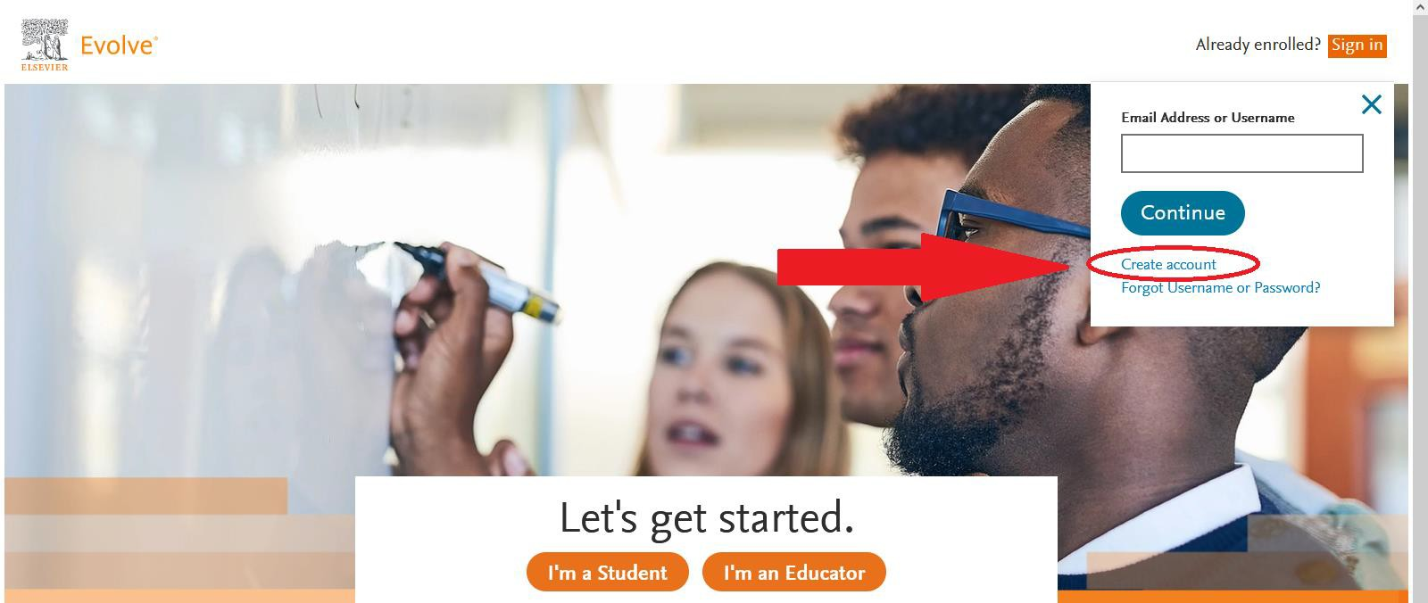

1. Register as a student, and fill in the required information. Click ‘Submit’

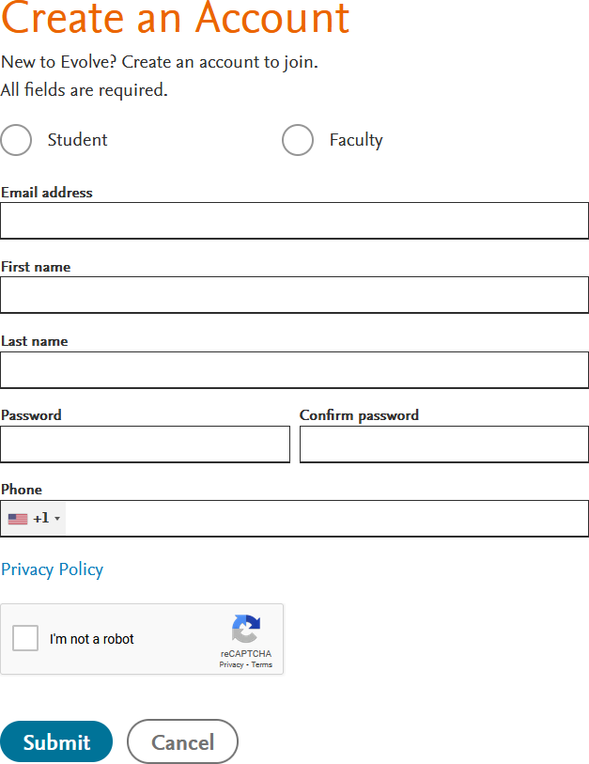

1. Write down/remember your username and password. You will need them on exam day. Click ‘Continue’

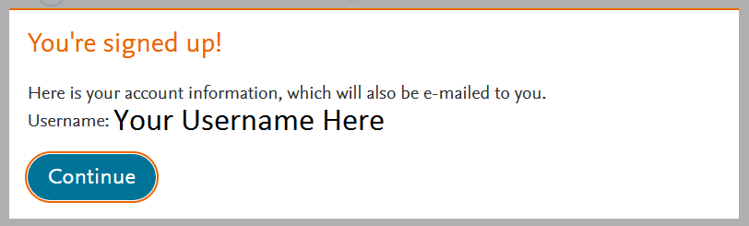

1. Click ‘Catalog’ on upper-right corner.

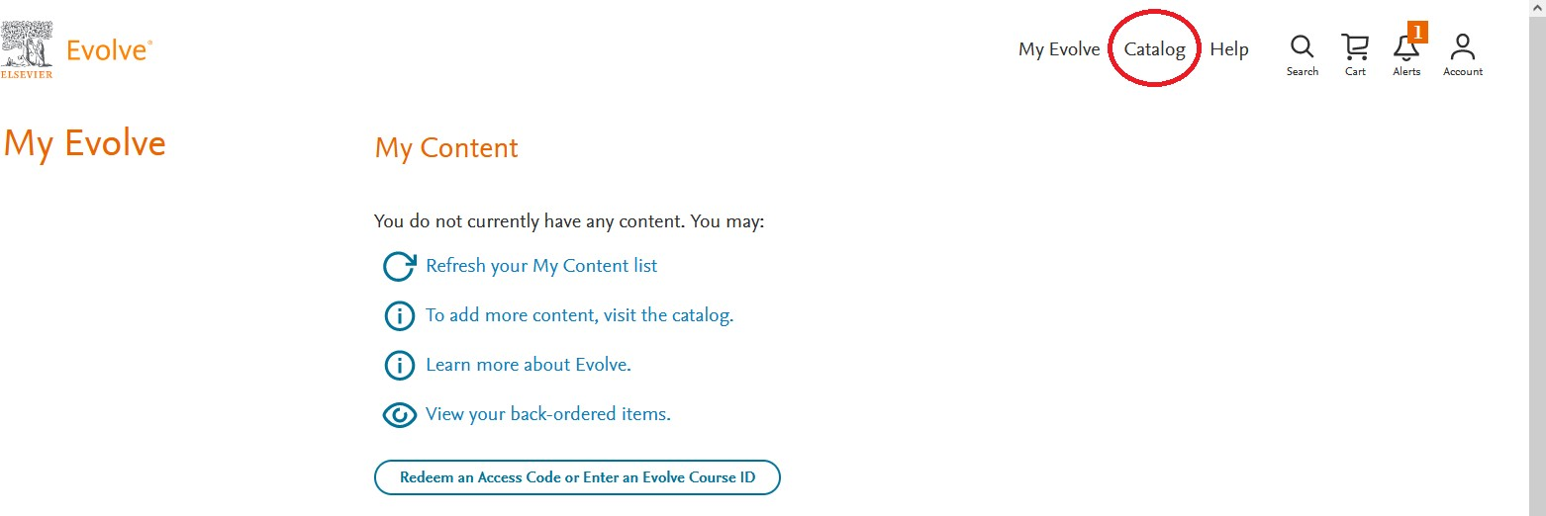

1. Under HESI Secured exams, click ‘Register for Results and Remediation’

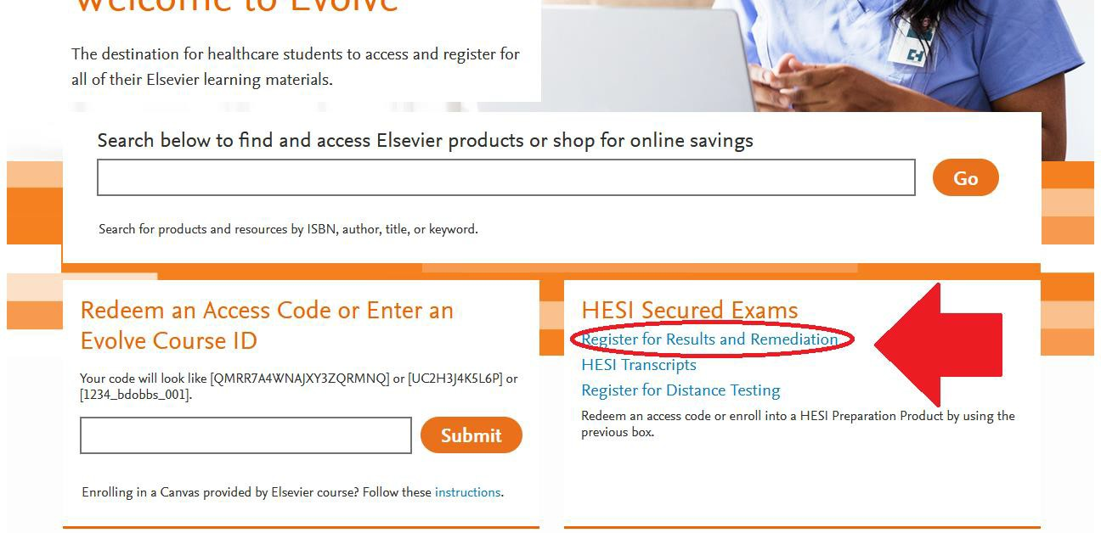

1. Click ‘REGISTER’

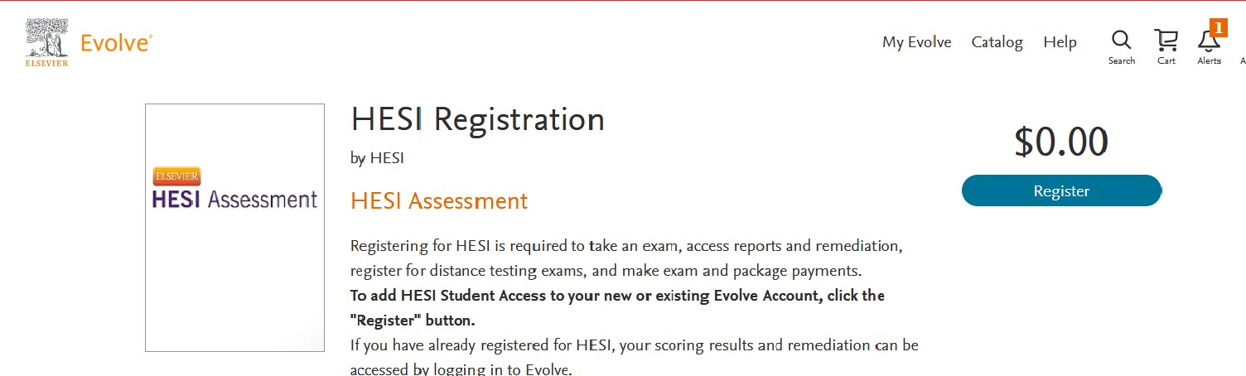

1. Click ‘Proceed to Checkout/Redeem’

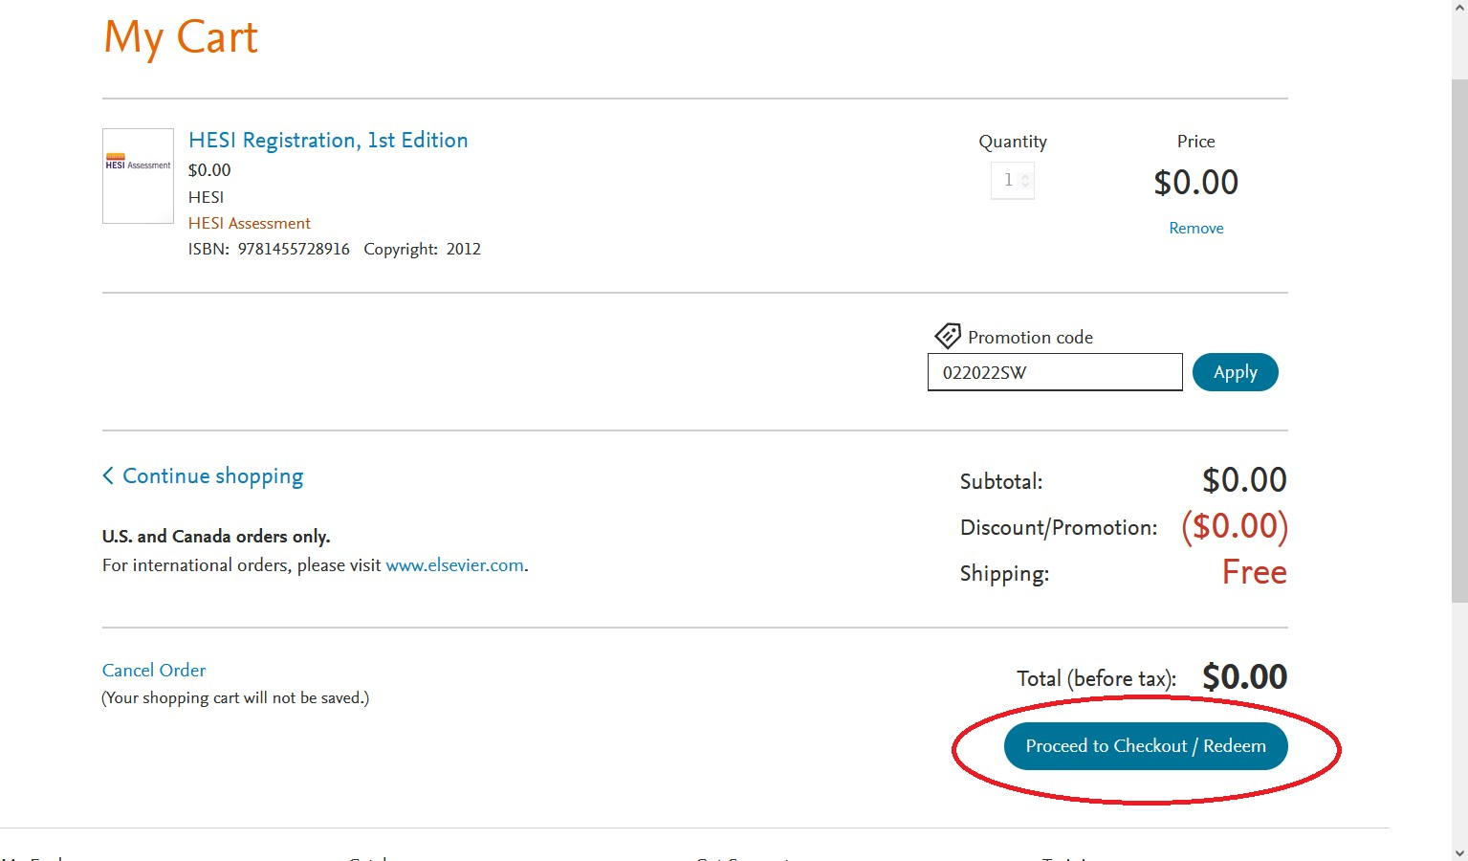

1. Update your account information in the spaces provided and then click ‘Continue’

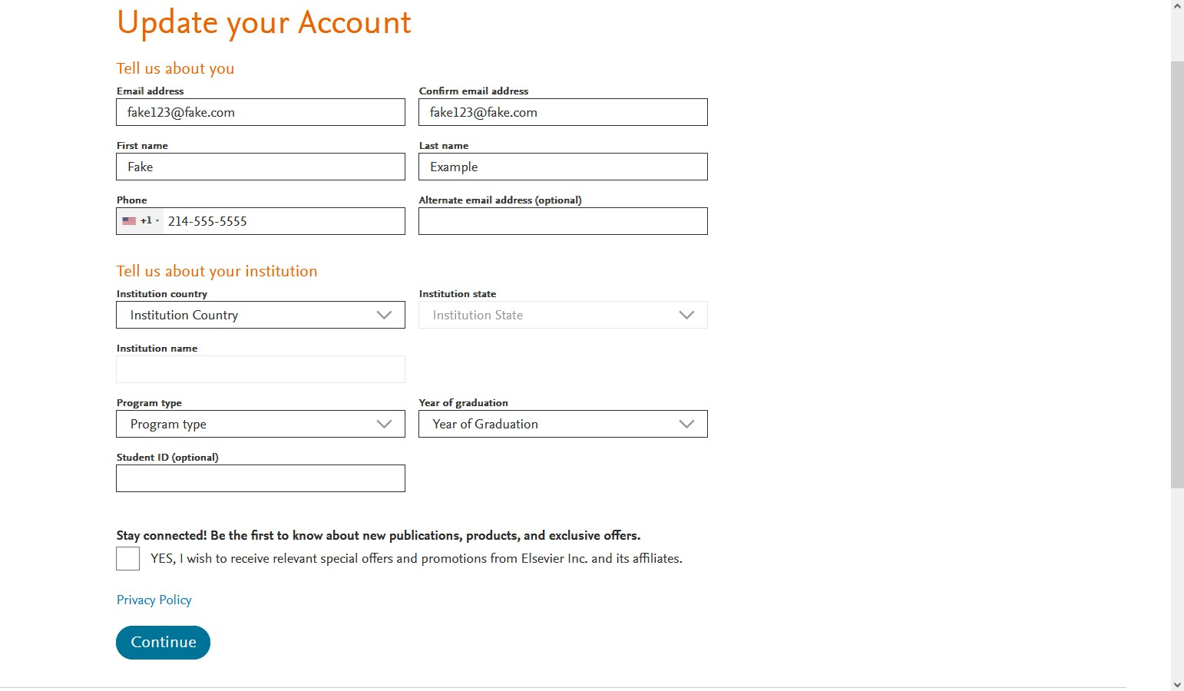

1. 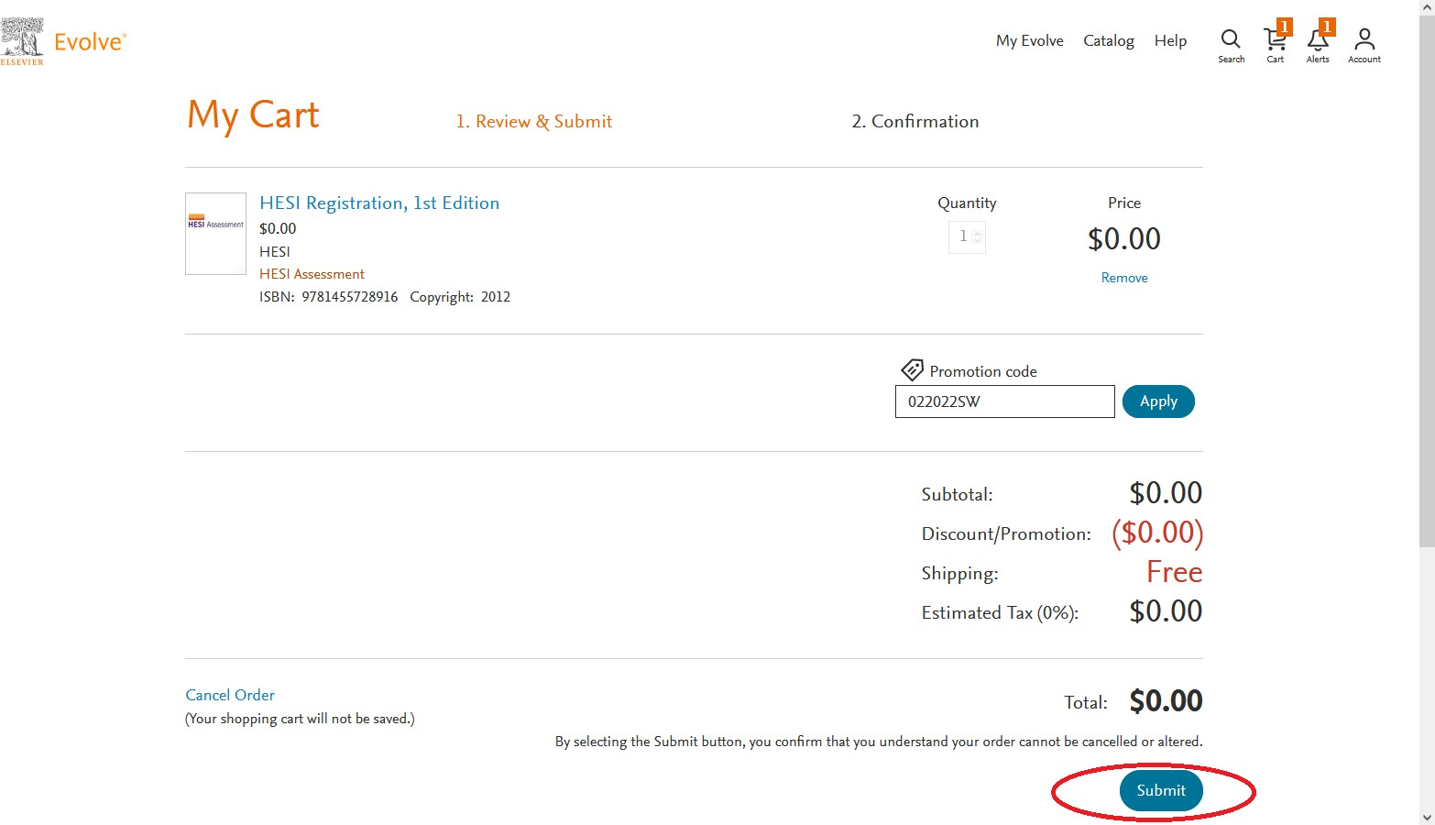Click ‘Submit’
2. You have now set-up your Evolve Student Account. Please note, you must now continue to register for the HESI exam by clicking ‘My Evolve’ and then ‘Student Access’. Please refer to the instructions concerning entering the payment ID for further information.

