Locating/ Entering and SAVE your Student ID Information in Evolve

1. Log into your student Evolve Account [HERE](https://evolve.elsiver.com)
2. Click the ‘Account’ on upper-right corner and click on ‘Account Settings’

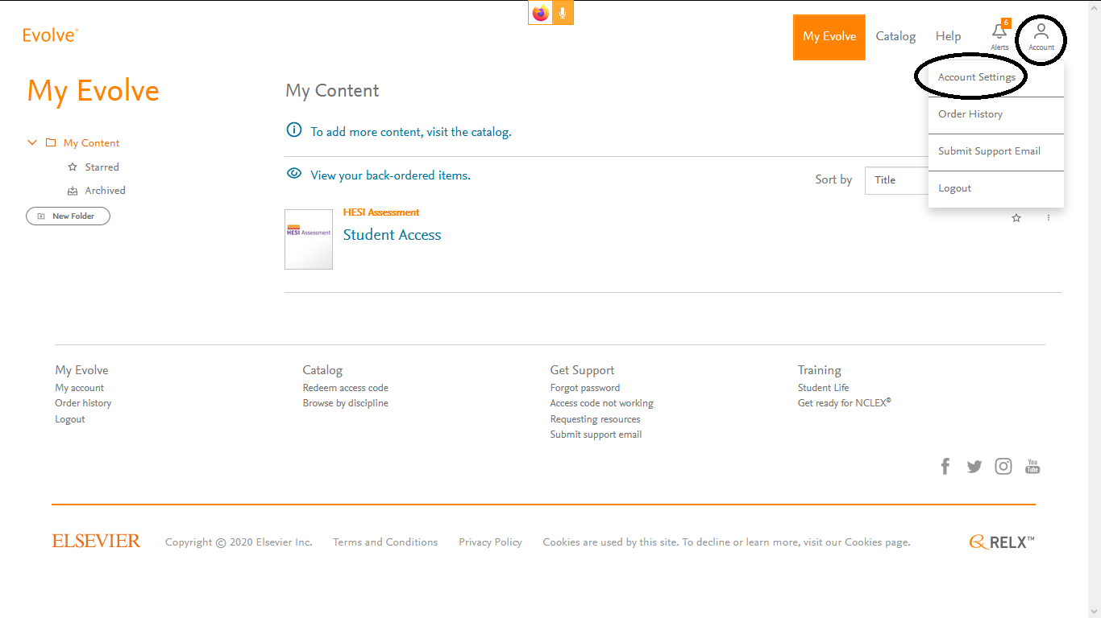

1. Fill out information under ‘Institution’ and click on ‘Continue’ on bottom of page.

