**NEW USERS:**

1. **Install theGoPass app on your mobile device.** Visit your Apple App Store or Google Play Store to download and install the GoPass app. Upon opening your app, you will be asked to enter your full name and zip code.
2. **Enter your e-mail address and create your password.** Please make sure to enter the email address provided to DART. Create your Password. Click SEND VERIFICATION CODE
3. **Verify your e-mail address.** A verification code will be sent to your e-mail/ Enter your verification code into the app.

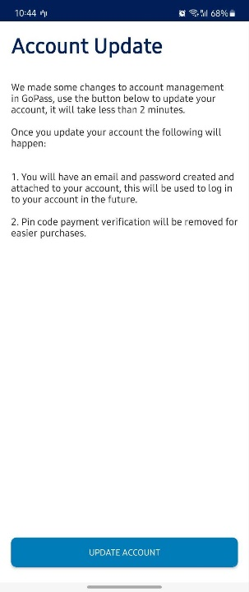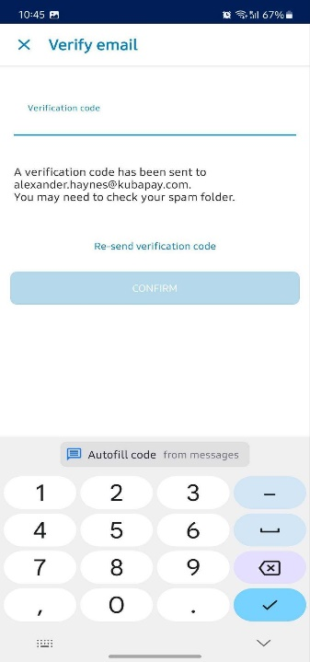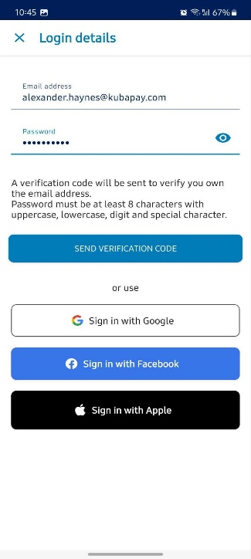

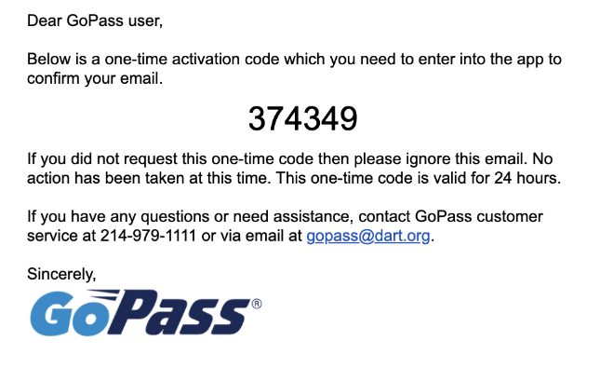

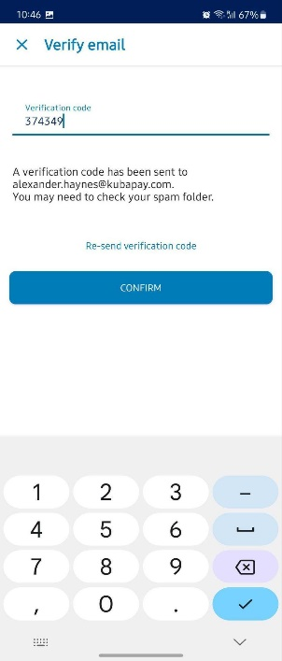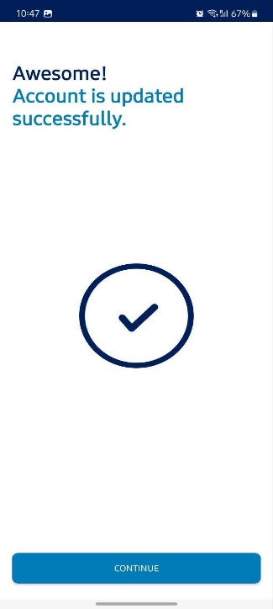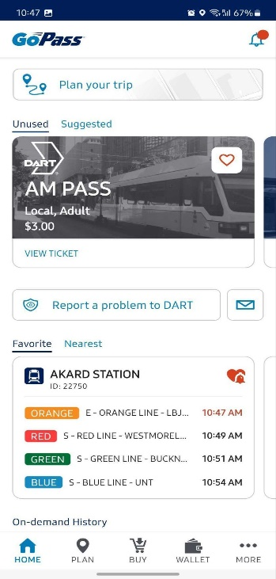

An email is sent to the employee email address. **Rider must**:

* Check for typos in the email address
* Ensure their inbox is not full and can receive messages
* Look in their spam folder

**PREVIOUS PASS USERS:**

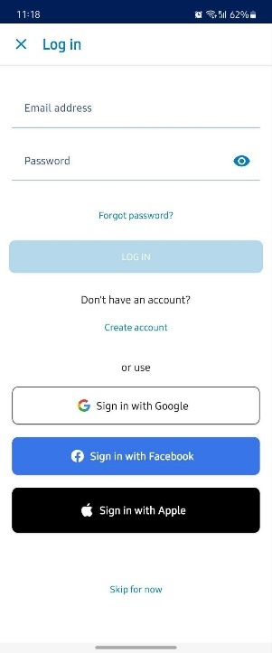The GoPass rider previously created an account using their phone number and has been using the app. At some point they deleted the app and now want to get back into the app to start using it again. The rider must “**Create account**”. During the registration their phone number is recognized.

1. **Logout of the app**
   * Open GoPass app, click on MORE
   * Click on YOUR PROFILE
   * Click on Logout
2. From the Log in screen, click **Create Account.**
3. **Enter Personal Details**
4. **Enter E-mail Address.**
   * Use email address that was provided to DART
   * Create your password
   * Click SEND VERIFICATION CODE
5. **Confirm** your mobile number
6. **Verify**.
   * A unique verification code will be sent to your mobile device

