FB*A*I*dvisory*

# If you receive a suspicious letter or package

What should you do?

No Return Address Restrictive Markings

Possibly Mailed from a

Foreign Country

Excessive Postage

## Handle with care Don’t shake or bump

1

Isolate and look for indicators

2

Don’t Open, Smell or Taste

3

Treat it as Suspect! Call 911

4

Oily Stains, Discolorations,

Misspelled Words

Addressed to Title Only or Incorrect Title

Badly typed or written Protruding Wires

Lopsided or Uneven Rigid or Bulky

Strange Odor

Wrong Title with Name

or Crystalization on Wrapper

Excessive Tape or String

# If parcel is open and/or a threat is identified. . .

### For a Bomb

Evacuate Immediately Call 911 (Police) Contact local FBI

For Radiological

Limit Exposure - Don’t Handle Distance (Evacuate area) Shield yourself from object Call 911 (Police)

Contact local FBI

For Biological or Chemical

Isolate - Don’t Handle Call 911 (Police)

Wash your hands with soap and warm water Contact local FBI

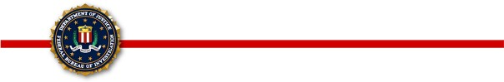

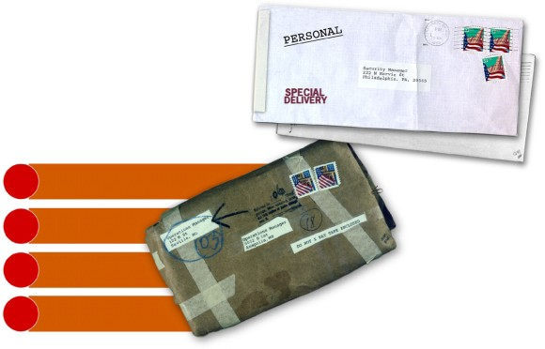

**Police Department Fire Department Local FBI Office**

**(Ask for the Duty Agent, Special Agent Bomb Technician, or Weapons of Mass Destruction Coordinator)**

GENERAL INFORMATION BULLETIN 2000-3

Produced by: Bomb Data Center

Weapons of Mass Destruction Operations Unit