|  |
| --- |
| Introduction |

This Job Aid (JA) is designed to walk **Prospective Suppliers and Purchasing Transaction Specialists** through the steps to submit a request to be a supplier**.** By the end of this JA, users will be able to successfully submit prospective supplier requests which would allow prospective suppliers to enter all of their own information, saving the time of Dallas College administrators.

|  |
| --- |
| Table of Contents |

Introduction 1

Table of Contents 1

Procedure: New (Prospective) Supplier Setup 1

|  |
| --- |
| Procedure: New (Prospective) Supplier Setup |

From the prospective supplier’s perspective:

1. Clicking on the link received lands you here. Click Sign In and the either sign in or create an account if it is your first time.

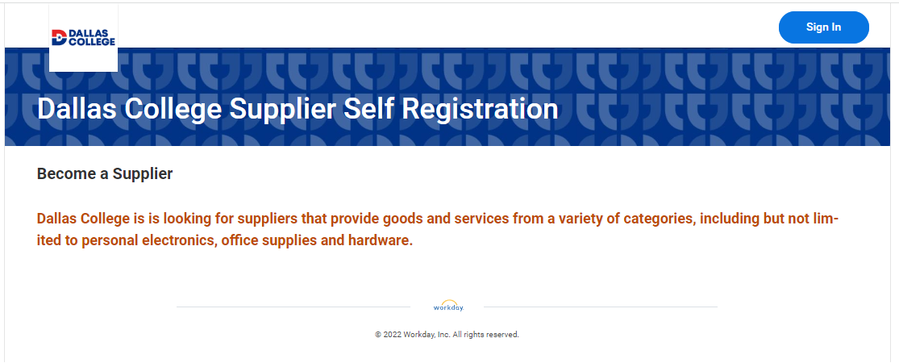

1. After creating an account with a username and password, you will be sent an email asking to verify your email address. Click on the link sent and then log in with your newly created account.

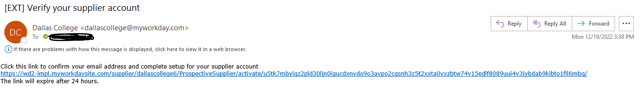

1. From here the prospective supplier will begin filling in their information.

* Begin with filling in business details.

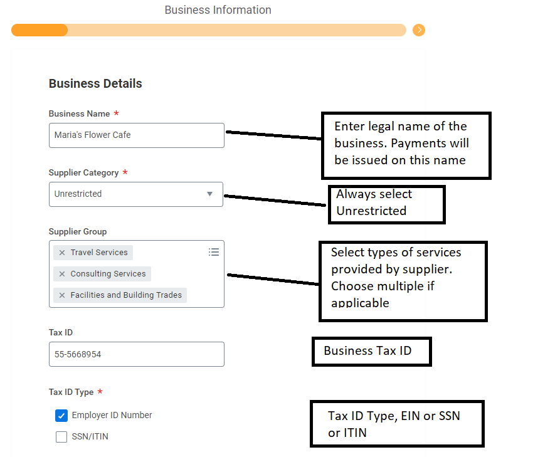

* Next, fill in payment types and currencies information

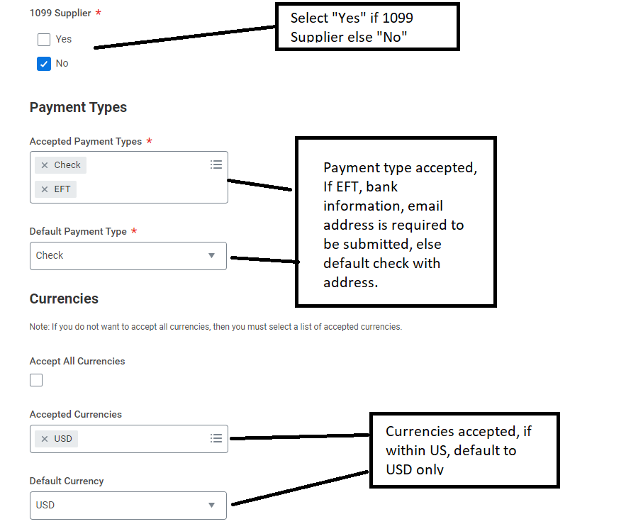

* Next, fill in contact information

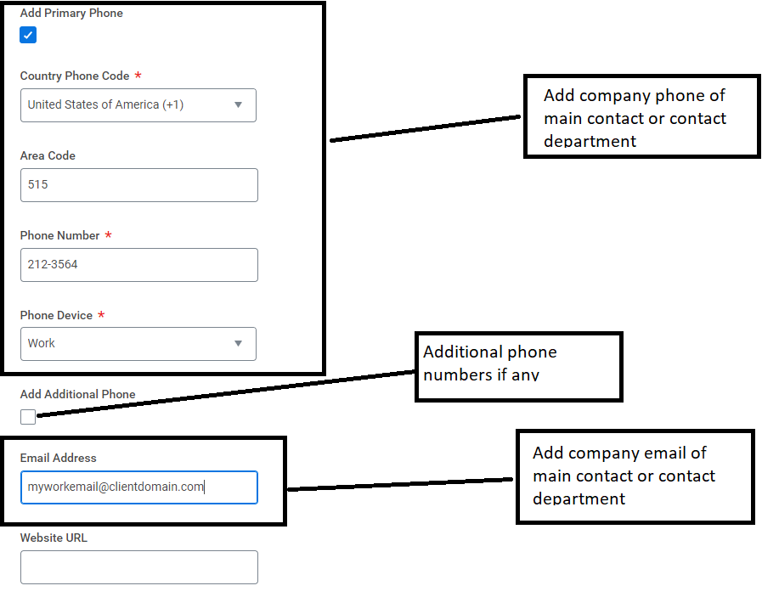

* Next, fill in address information.

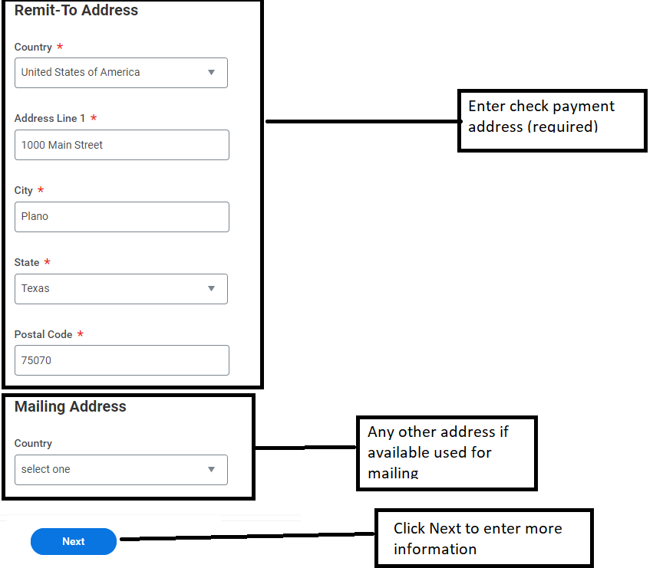

* Next, add classifications if any. Select appropriate classification and enter information, if none, click remove button. Multiple classifications can be selected by clicking “add”.

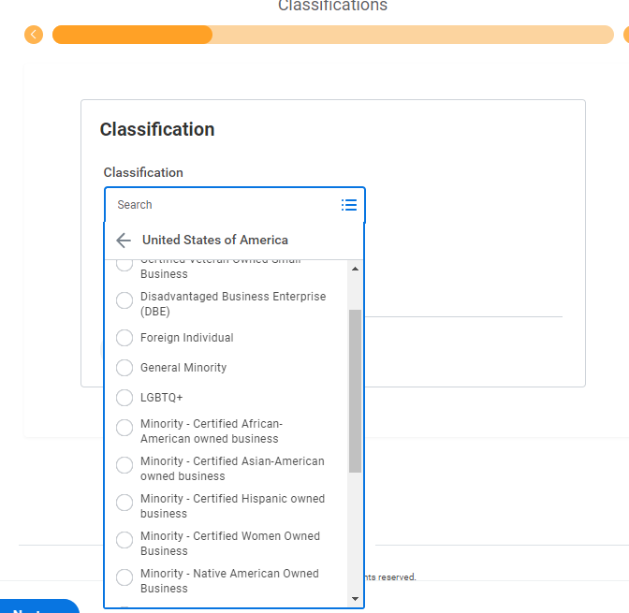

* Next, enter banking information if ACH/EFT/Wire payment is selected. If “Check” is selected, leave blank and click “Next”.

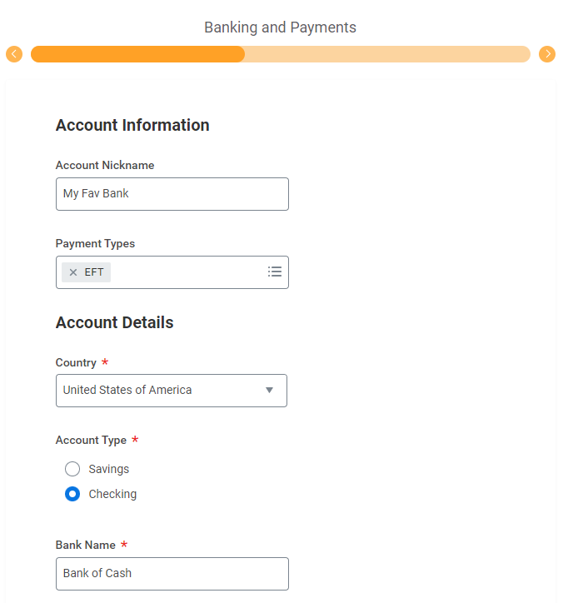

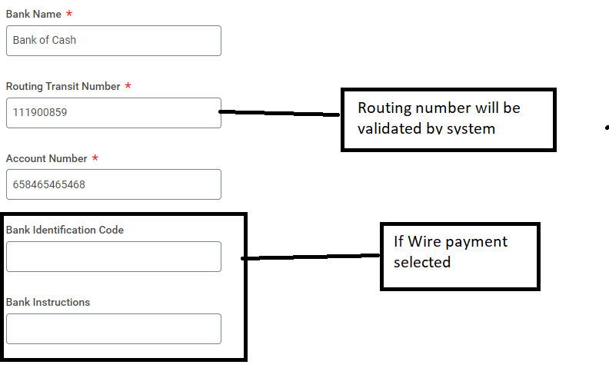

* Next, enter any contact person information to refer any queries with the account, blank information could delay approval of supplier. Mailing address is not required.

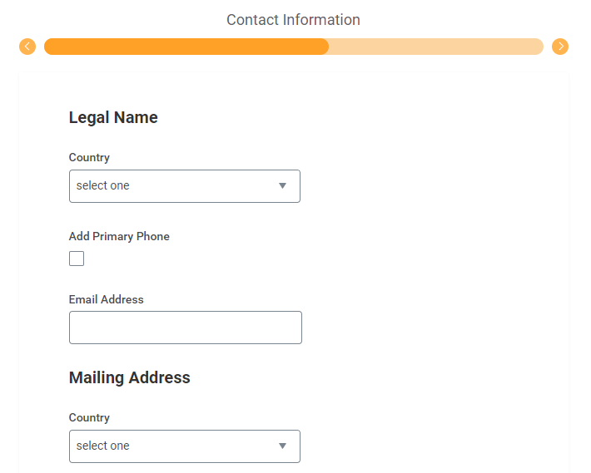

* Next, attach W-9 or any other tax and legal documents

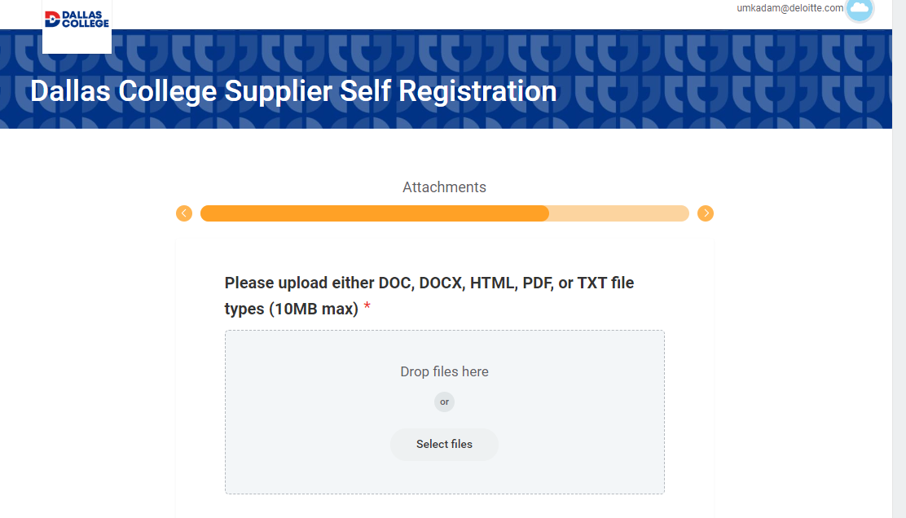

* Next, accept the terms and conditions and sign the request.

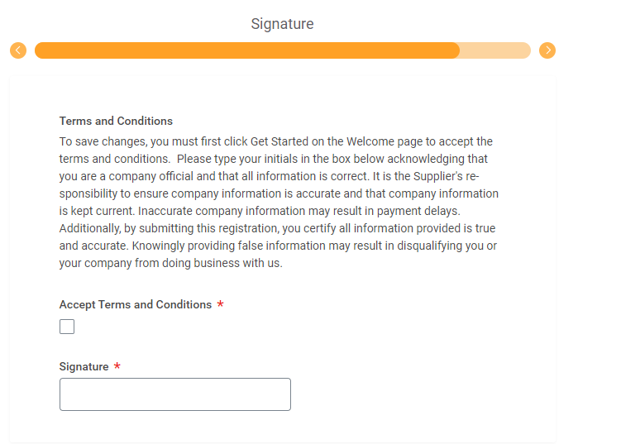

* Review all the entered information and click “Submit” at the bottom of the page to submit the supplier request.

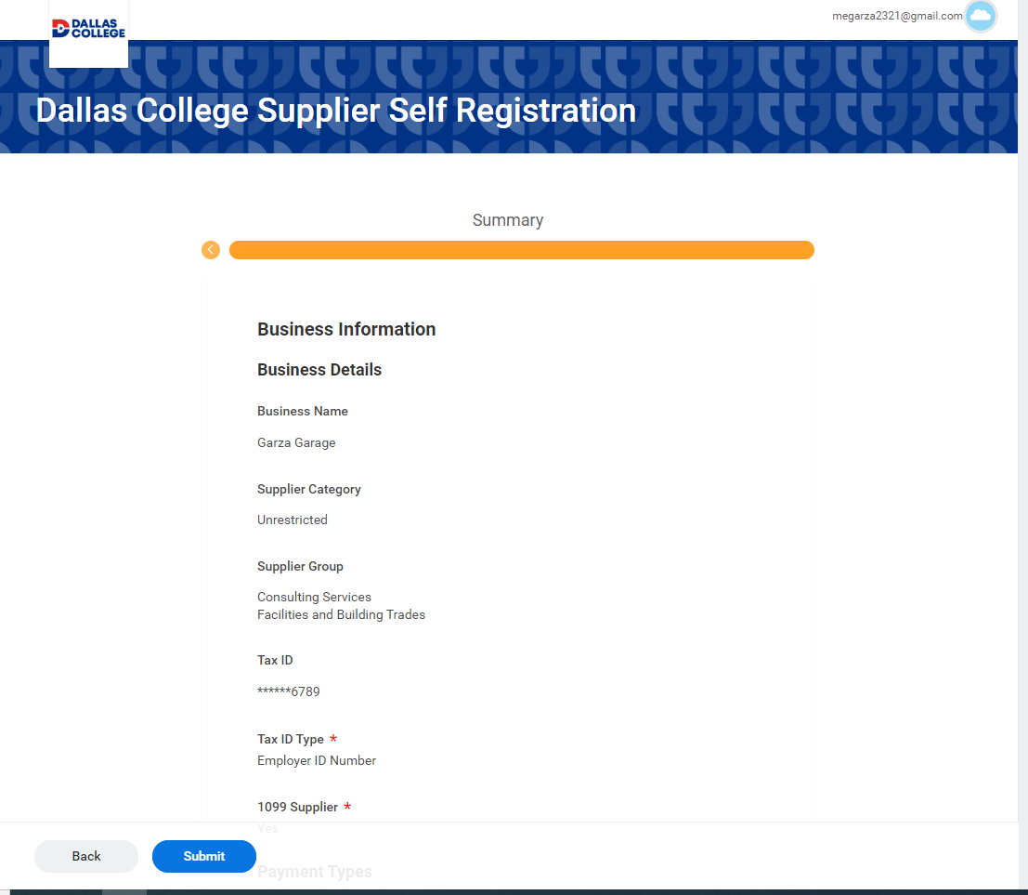

* You have successfully completed this task. It will now be up to the administrators to review and approve the request.

